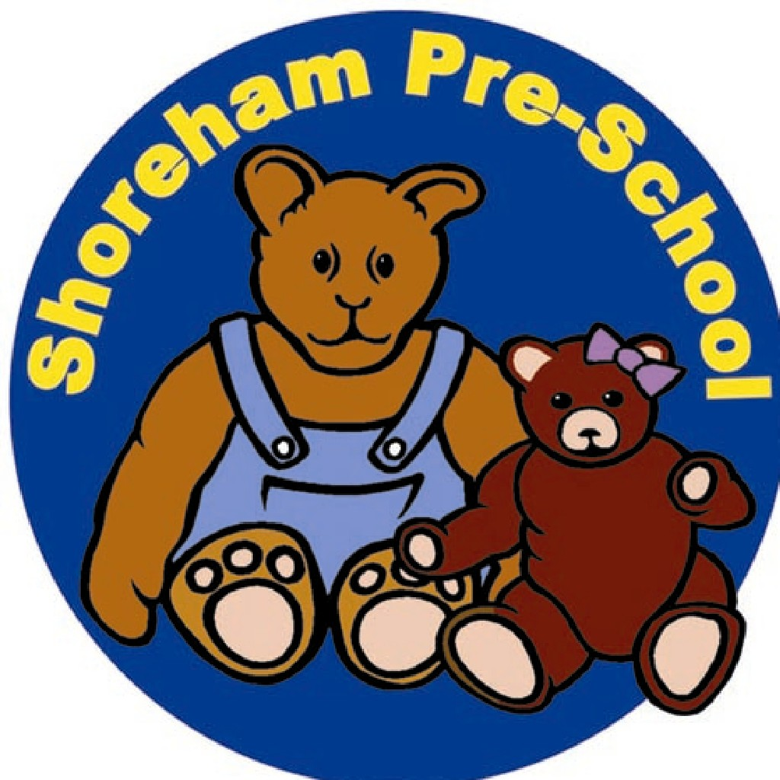

7.2 Record Keeping Policy

Records for individual children should be a positive way of identifying what children have achieved, what they understand and can do and what their ‘next steps’ for learning are. Over a period of time they can also indicate how the children have progressed, the rate at which they have progressed and where children may need extending in their learning, or need further help.

Learning Journals
Each key worker will keep written observations about their children in their Learning Journal and will coordinate home/Pre-School liaison and opportunities for home learning.
Every week, each key worker will focus on two of their children in rotation. At a weekly planning meeting, each key worker will reflect on observations made about their focus children and then devise activities to extend their learning. Records for these observations and planning for the individual child will be kept in the child’s Learning Journal. Annotated photographs of the children will be kept as evidence of their learning. Each child will have an individual folder for samples of work, these will be annotated and dated.
The key worker will be responsible for a Learning Journal for each of the children she oversees.
Contents of the Learning Journal should provide evidence that the child is working towards the Early Learning Goals as set out in the EYFS. This evidence will be in the form of,
- Samples of work
- Drawings
- Paintings
- Photographs
- Written observations
- Written comments from parents

This evidence will be used to inform parents of a child's
progress and the parent may wish to contribute comments or a sample of work, comment
about an incident, or occasion from home.
The key worker will write a report for each of her children on leaving the Pre-School to
start school. Each family will receive a copy of this and a copy will be given to the child’s
next school along with the Progress Tracker and Next Steps in Learning. Photographs
will be turned into a memory book and given to the family as keepsake.
Please see our Data Protection Policy for further information.
Retention of Records
- Children’s records ; including registers, medication records, accident books will be kept securely until the child reaches the age of 21 or in the case of Safeguarding the age of 24. (Limitation act 1980, childcare Act 2006)
- Records of any reportable death, injury, disease or dangerous occurance; will be kept for 3 years after the date the record was made (The Reporting of injuries, Diseases and Dangerous Occurrences Regulations 1995 (RIDDOR)
- Personnel files and training records (Including disciplinary records and working time records); will be kept for 6 years after employment ceases.
- DBS Checks; will be kept for 6 months (DBS code of practice) The following basc information should be kept after the certificate is destroyed; the date of issue, the name of the subject, the type of disclosure, the position for which the disclosure was requested, the unique reference number and the details of the recruitment decision taken.
- Staff wage records including overtime; will be kept for 6 years (Taxes Management Act 1970)
- Statutory Maternity Pay; 3 years after the tax year to which they relate. (SMP Regulations 1986)
- Statutory Sick Pay Records; 3 years after the tax year to which they relate. (SSP Regulations 1982)
- Income Tax and National insurance Records; will be kept for at least 3 years after the end of the tax year to which they relate. (Income Tax (Employments) Regulations 1993
- Accident/ Medical Records; will be kept for 40 years after last entry. (The Control of Substances Hazardous to Health Regulations 2002 (COSHH)
- Accounts; will be kept for 3 years from the end of the financial year for private companies. ( Companies Act 2006)
- Employers’ liability Insurance Records; will be kept indefinitely.

Any records which are not required to be archived and stored securely will be shredded and disposed of. We use a cross cut shredder which conforms to data protection requirements.

