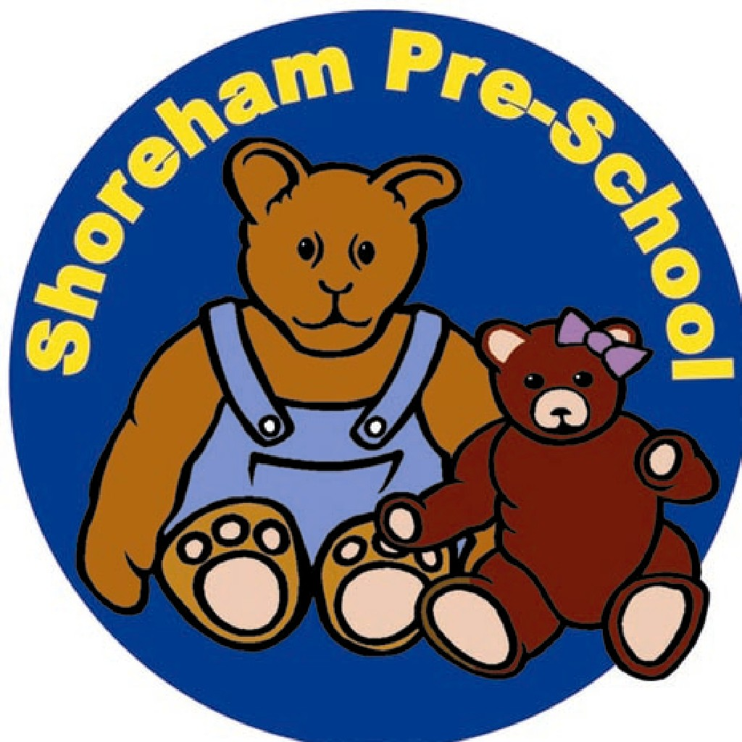

**4.2 Assessment & Planning Policy & Learning Journals**

Our Pre-School plans to provide the children attending our sessions, opportunities that will support and promote their overall development in a safe, stimulating and caring atmosphere, created by appropriately trained, knowledgeable staff with the involvement of all families within our community who are interested in and support our aims.

We take care to provide activities which use equipment appropriate to the age and stage of development of the children attending our Pre-School which will stimulate their interest and encourage investigation, as well as enabling, the children to practice existing skills, and to build on those skills to acquire new ones.

We are aware of the importance of reflecting all members of society, not just those that attend our group, but also the local community and society in general in a positive way. We ensure that activities, equipment and displays provide a balanced view and also allow children to show their own individual creativity without pressure to have an adult directed "perfect" end product.

All children need to experience activities and experiences tailored to their stage of development and taking account of their individual needs, the play activities provided by our Pre-School are an essential element of the pre-school experience.

We follow the Early Years Foundation Stage Curriculum and Development Matters documents and all our planning and assessment adheres to national guidelines. As a staff, we keep abreast of current thinking, recommendations and research through reading published periodicals and by continuing to update our training.

We have an Action Plan based on our last Ofsted report, which shapes our future planning, and development of the Pre-School.

Our planning is based on the individual and group needs of the children.



**Key worker**

After a settling in period where staff will observe which member of staff a child is drawn to, every child will be allocated a Key Worker. Key workers are responsible for the care and liaison of each family and will keep Learning Journals and planning up-to-date. Key workers will also liaise with Outside Agencies and other settings as required.

**Learning Journals**

Every child will have their own Learning Journal where all observations, planning and assessment will be kept. Parents have access to these journals and are welcome to take them home to look at with agreement from their child’s Key Worker.

If a child attends another setting, the setting where the child spends the majority of their time will take the lead with the planning and assessment for the Learning Journal. Their Key worker will ask for a copy of the child’s Next Steps planning from their main setting and keep observations and plan activities accordingly on a termly basis. Copies of records will be sent to the main setting termly.

**Parent liaison**

Key Workers will give each child where Shoreham Pre-School is the main setting a copy of their planning to take home for parents to read and add their comments to. Parents are encouraged through Newsletters, notices and texts to come in regularly to discuss their child’s progress.

**Report**

In the summer term before a child starts school, Key Workers will write a report for each child. A copy will be given to parents and a copy sent to the child’s new school**.**

**Planning from the Child’s Perspective**

When a ‘fascination’ has been identified, staff will work with those children interested to map what they already know about E.g. sea creatures. Children are encouraged to contribute orally, and to add their own pictures or writing.

Adult will ask, ’What would you like to find out?’ and record. Adult will then facilitate the children finding the answers to their questions and record further questions and answers which may occur.